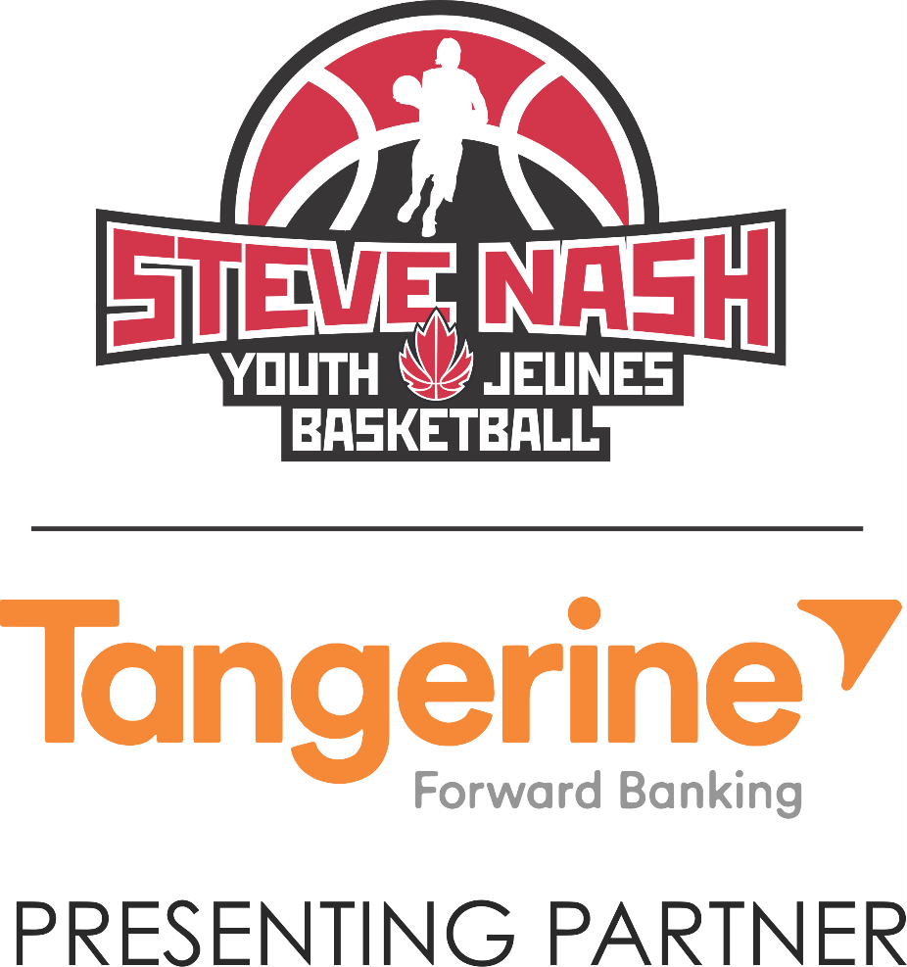

**Season Handbook**

**Affiliate Member Handbook**

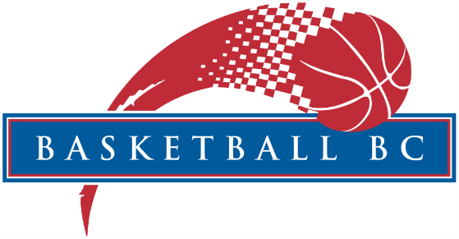

Table of Contents

WELCOME 3

COST/BENEFITS 4

What You Need To Start a SNYB Program 5

SNYB Program Checklist 5

SNYB COACHING RESOURCES 6

NCCP Coaching Clinics 6

Suggested Rules for SNYB 7

Contact Information 8

APPENDIX B: Participation and Coaching List 10

APPENDIX C: Affiliation Agreement 11

# WELCOME

The Steve Nash Youth Basketball season is just around the corner and we are looking forward to another great year.

We anticipate 30+ communities and 7000+ athletes participating in Steve Nash Youth Basketball throughout BC.

As most of you are aware the Tangerine sponsorship with Canada Basketball involves a number of things – and one of those is sponsorship with SNYB. We are still understanding some of the intricacies of the sponsorship and, more important, what it means to us. If you have any questions about this sponsorship agreement, please let me know.

Please take a few minutes to review this handbook as the information included will serve as a reference and will also indicate a few administrative duties required during the program.

Basketball BC is extremely appreciative of the dedication, commitment and time given by key administrators such as you, to help grow basketball in our province. Thank you for your hard work!

If you have any questions or concerns throughout the year, please feel free to contact me at srudnisky@basketball.bc.ca or 604-455-2813

Stephanie Rudnisky  
Basketball BC  
Manager, Special Events and Youth Programs

# COST/BENEFITS

There is no start-up cost or annual fee. Just a simple rate per participant.

The program fee for 2016-2017 is **$38/participant.**

|  |  |  |
| --- | --- | --- |
| **Participant** | **Coaches** | **Administrators** |
| * A numbered reversible Steve Nash Youth Basketball Jersey * Basketball BC Steve Nash Youth Membership* * Comprehensive insurance/liability coverage up to $5,000,000 | * Comprehensive insurance/liability coverage $5,000,000 * Access to Basketball BC SNYB Coaches Manual & Lesson Plans * Tangerine Coaches Kit * Reduced rate on NCCP clinics (Refer to Page 7) * Free Basketball BC Membership** | * Access to bulk discount on equipment, apparel and basketballs * Comprehensive insurance/liability coverage $5,000,000 |
| *Steve Nash Youth Membership includes discounts for apparel, partner events/games and discounts on travel and accommodation from September 1st 2016-August 31st, 2017.  **Coach List with all information filled in must be received in order to process FREE Basketball BC Coach Membership. **Coach Memberships are valid from April 1-March 31.** | | |

# What You Need To Start a SNYB Program

* Gym Facility
* Basketballs
* Coaches
* Administrator

# SNYB Program Checklist

* Submit Signed Affiliation Agreement – Prior to registration
* Update Program Contact Information – Prior to registration
* Review Branding Guidelines
* Place Order for Jerseys
* Place Product Order Directly with Big Kahuna (See contact page)
* Submit Coaching List – ASAP email to srudnisky@basketballbc.ca
* Submit Participation List – ASAP email to srudnisky@basketballbc.ca
* Send Media to Basketball BC – when available to srudnisky@basketballbc.ca
* Pay Invoice within 30 days of receiving Jerseys
* Complete an End of Season Survey

# SNYB COACHING RESOURCES

All SNYB Coaching Resources can be found online: <http://www.basketball.bc.ca/snyb-resources>

# NCCP Coaching Clinics

New this year any Steve Nash Groups that have 15 or more coaches who are interested in the Fundamentals NCCP Course or the Learn to Train NCCP Course can receive training at a significantly reduced rate. Basketball BC must receive your coach list prior to facilitating a NCCP Clinic.

Fundamentals – 1 Day Course ($75) – regular course fee $175

Learn to Train – 2 Day Course ($100) – regular course fee $200

How to set up your NCCP Coaching Clinic:

1. Interest from 15 **SNYB coaches** (May combine with other interested SNYB groups)
2. Facilities including a classroom and a basketball court which must be provided by the SNYB group
3. Contact Stephanie at [srudnisky@basketball.bc.ca](mailto:srudnisky@basketball.bc.ca)

Please allow for a 30-day lead time. Clinic dates will depend on the availability of NCCP course facilitator.

# Suggested Rules for SNYB

|  |  |  |  |
| --- | --- | --- | --- |
| **Technical (subject to available facilities)** | | | |
| **Rules** | **Gr 2/3** | **Gr 4/5** | **Gr 6/7** |
| Basket Height | 8-8.5 | 9 | 10 |
| Ball | 5 | 5 | 6 |
| Court | elem | elem | elem/hs |
| **Play** | | | |
| **Rules** | **Gr 2/3** | **Gr 4/5** | **Gr 6/7** |
| Time Outs/Half | 2/1st, 3/2nd | 2/1st, 3/2nd | 2/1st, 3/2nd |
| Defense | no zone | no zone | no zone |
| Full Court Pressure | No | No | Yes |
|  |  |  | No Double Teaming |
| 3 Second | Relaxed | Yes | yes |
| Start Game | Jump Ball | Jump Ball | Jump Ball |
| Alternating possession | Yes | Yes | Yes |
| Fouls | Call-Teach | Call-Teach | Call |
| Record Fouls | No | No | Yes |
| Foul Shots | No | No | Yes |
|  |  |  | Shooting only |
| Intentional Fouls | Warn | Warn | 2 Shots |
| 30 second clock | No | No | Yes |
| Half Court 8/10 sec | No | No | 10 (try 8) |
| Stalling | Warn then possession | Warn then possession | Warn then possession |
| Screening | Yes | Yes | Yes |
| Keep Score | No | Yes | Yes |
| 3 Point Shots | No | Yes | Yes |

Different combinations of Grade levels should adjust their rules accordingly

It is **not** assumed that all levels will play regular games. At the Grade 2/3 level, programs may consider practice and inter-squad games as most beneficial.

It is also recommended that during play coaches/officials use “the teachable moment” concept to reinforce particular rules of the game. Done correctly, this should be short, clear and without judgement.

Post grade 7 leagues/associations are encouraged to use FIBA rules

# Contact Information

**SNYB Program Contact at Basketball BC**

Contact: Stephanie Rudnisky

Email: srudnisky@basketball.bc.ca

**Ball Orders to Big Kahuna**

Contact: Tyler McLaren

Phone Number: ***604.536.2441***

Email: tyler@bigkahuna.ca

Website: <http://www.bigkahuna.ca/>

**Official SNYB Gear Online Store:**

<http://urstore.ca/sports/ca/british-columbia/langley/basketball-bc-official-online-apparel-store/>

**Online Resources and Forms Download**

<http://www.basketball.bc.ca/snyb-resources>

APPENDIX A: Jersey Order Form

Please submit the following form to [srudnisky@basketball.bc.ca](mailto:srudnisky@basketball.bc.ca) or by fax. The excel version can be downloaded from our [online resource centre](http://www.basketball.bc.ca/snyb-resources).

|  |  |  |  |  |  |  |
| --- | --- | --- | --- | --- | --- | --- |
| **JERSEY ORDER FORM 2016-17** | | | | | | |
|  | | | | | | |
| **Program/Name** |  | | | | **Date** |  |
| **Ship or Free Pick Up** |  | | | |
| **Ship to Address (include Postal Code)** |  |  |  |  | **Ship to Phone #** |  |
|  |  |  |  |
|  |  |  |  |
| **Residential or Commercial Address** |  | | | | **Jersey Colour Pref.** |  |
| **E-mail** |  | | | | | |
| **INV#** | **DESCRIPTION** | | | | | **QTY** |
|  |  |  |  |  |  |  |
| YXS | Youth Xtra Small-Jersey | | | | |  |
| YS | Youth Small-Jersey | | | | |  |
| YM | Youth Medium-Jersey | | | | |  |
| YL | Youth Large-Jersey | | | | |  |
| AS | Adult Small-Jersey | | | | |  |
| AM | Adult Medium-Jersey | | | | |  |
| AL | Adult Large-Jersey | | | | |  |
| AXL | Adult Xtra Large-Jersey | | | | |  |
|  |  |  |  |  | **JERSEY TOTAL** |  |
| ***Shipping $: (Varies by location or free pick-up)*** | | | | |  |
| ***Please note jerseys will be shipped via Greyhound Courier and arrive in 2-5 business days from order date.*** | | | | | |

# APPENDIX B: Participation and Coaching List

Excel files of these forms may be obtained from our SNYB [online resource center](http://www.basketball.bc.ca/snyb-resources).





# APPENDIX C: Affiliation Agreement

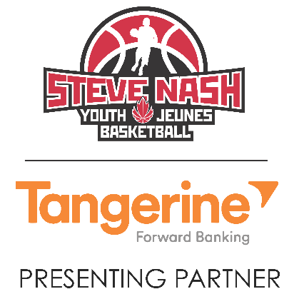

**AFFILIATION AGREEMENT**

**I. GENERAL**

1. This Agreement outlines the terms and conditions on which Basketball BC partners with ______________________________ (the “*Affiliated Site*”) to deliver and operate the Steve Nash Youth Basketball program (SNYB).
2. *Term*. The term of this Agreement shall commence on ***September 1, 2016*** and shall expire on ***August 31, 2017*** unless terminated earlier in accordance with the provisions herein (the “Term”). An evaluation will be conducted by *Basketball BC* at the end of the term to govern the guidelines of this Agreement and ensure that all deliverables have been met accordingly.
3. *Ownership*. The *Affiliated Site* acknowledges that *Basketball BC* has sole rights to own, manage and control all aspects of Steve Nash Youth Basketball including the program content, the SNYB name, approved logo, and all other associated properties of SNYB created under this Agreement. All SNYB program related materials used by the *Affiliated Site* is by express consent as set out in this Agreement. All materials created by the *Affiliated Site* under this Agreement for the SNYB program shall be a “work made for hire” for *Basketball BC* reserve all rights, titles, and interests (including, without limitation, all copyrights and trademarks) in any and all subsequently created materials. The *Affiliated Site* agrees that it shall honor the requests of *Basketball BC* in registering, establishing, securing, defending, enforcing or otherwise protecting all of *Basketball BC’s* property rights associated with the SNYB program presently existing or subsequently created under this Agreement by the *Affiliated Site* or *Basketball BC*.
4. *Sponsorship*. It is the sole right of *Basketball BC* to market and sell sponsorship rights associated with Steve Nash Youth Basketball. The *Affiliated Site* may not in any circumstances sell sponsorship or attach a sponsor to the SNYB name and program without receiving prior written approval of *Basketball BC*.
5. Marketing/Branding. The affiliated site must adhere to all terms set out in the *Basketball BC Branding Guidelines*.

**II. AFFILIATED SITE RIGHTS & OBLIGATIONS:**

Upon execution of this Agreement and thereafter during the term of this Agreement:

1. The *Affiliated Site* shall, subject to all limitations and restrictions imposed by *Basketball BC* pursuant to the terms of this Agreement, be authorized to implement and deliver Steve Nash Youth Basketball and be solely responsible for ensuring the safety of the participants and quality control while implementing and delivering all elements of the SNYB program.
2. The *Affiliated Site* shall reimburse *Basketball BC* a registration fee of **$38** per participant who joins Steve Nash Youth Basketball. This fee covers the cost of all SNYB program materials, manuals, provincial membership, national membership, as well as liability insurance for all coaches and participants in the program.
3. The *Affiliated Site* shall actively promote and communicate Steve Nash Youth Basketball within the community to attract participants to sign up for SNYB.
4. The *Affiliated Site* shall be responsible for all recruitment of coaches and volunteers for Steve Nash Youth Basketball. The *Affiliated Site* shall work closely with *Basketball BC* in registering all its coaches in SNYB to the New NCCP Fundamentals clinic.
5. The *Affiliated Site* will be required to submit to *Basketball BC* ALL intellectual coach/player information that is collected for the administration of the SNYB Program. All data submitted must be complete and accurate, satisfying the operational requirements of *Basketball BC* and the SNYB Program.

It is the responsibility of the *Affiliated Site* to collect all intellectual coach/player information by their means, and input all required fields into the SNYB Registration Database excel file. This electronic file will be given to the Affiliated Site organizer prior to registration and the submission of the completed file must be sent to *Basketball BC* within **60 days of the registration date**. The Affiliated Site can not proceed with their SNYB program until this data has been received.

1. The Affiliated Site shall be responsible for all inventory control and logistics including ordering, receiving and distribution of all program materials to its registered participants and coaches.
2. The *Affiliated Site* shall at all times adhere to the core values of Steve Nash, the Steve Nash Foundation, and *Basketball BC* in the implementation and operation of SNYB.

**III. BASKETBALL BC RIGHTS AND OBLIGATIONS:**

Upon execution of this Agreement and thereafter during the term of this Agreement:

1. *Basketball BC* shall, subject to this agreement, provide the *Affiliated Site* with all reasonable access to Steve Nash Youth Basketball properties for it’s operational use, including access to the following:
   * Approved SNYB logo, images and artworks;
   * Approved SNYB program resources – operations manuals, coaches manuals, parent’s guides;
2. *Basketball BC* shall provide liability insurance coverage for all participants, coaches and administrators of Steve Nash Youth Basketball.
3. *Basketball BC* shall carry provincial marketing campaign that will assist in the promotion and development of Steve Nash Youth Basketball.

**IV. TERMINATION RIGHTS**

If the *Affiliated Site* during the term of this Agreement fails in a significant and material way to observe, perform or respect the terms and conditions contained herein, *Basketball BC* shall notify the offending party in writing of such failure. The *Affiliated Site* in breach shall have 30 days to correct its identified failure. If the *Affiliated Site* in breach fails to correct the failure within the thirty (30) day period *Basketball BC* shall have the right, on providing written notice of the ongoing default, to elect to immediately terminate this Agreement.

Further, in the event that either party repeatedly fails to observe, perform or respect the terms and conditions contained herein, the other party shall have the right, on providing sixty (60) days written notice of the persistent ongoing defaults, to elect to terminate this Agreement. Each party confirms that it will act reasonably in this regard as it is their mutual intention to work together throughout the full term of this Agreement for the betterment of basketball in British Columbia.

It shall be a condition of this Agreement that the details of this Agreement are held by the parties in strict confidence.

**V. MISCELLANEOUS**

(a) Severability. If any provision of this Agreement is invalid, the remaining provisions shall be unimpaired, and the parties will negotiate in good faith to substitute a provision of like economic intent and effect.

(b) Relationship of the Parties. This Agreement does not create a legal partnership, agency, joint venture or similar relationship between the parties, and no party shall have the power to obligate or bind the other party.

(c) Binding Agreement. This Agreement is binding upon and inures to the benefits of the parties hereto and their respective successors and permitted assigns. It is the parties’ explicit intention that no other person or entity is entitled to bring any action to enforce any provision of this Agreement, and that obligations set forth in this Agreement are solely for the benefit of, and enforceable only by, the parties hereto or their respective successors or permitted assigns.

(d) Assignment. Neither party may assign this Agreement or any of its rights hereunder unless the other party consents in writing to the assignment before such assignment is made. Any attempted assignment, delegation, sublicense or other transfer without such required consent shall be void.

(e) Amendment; No Waiver. Any amendment to this Agreement must be in writing and signed by both parties. No failure or delay by either party in exercising any right hereunder shall operate as a waiver thereof, and no single or partial exercise of any right shall preclude any other or further exercise thereof or the exercise of any other right hereunder.

Thank you once again for your support. We are extremely excited to work with you and your team to develop a mutually beneficial relationship in growing grassroots basketball in British Columbia through the Steve Nash Youth Basketball program. If you are in full agreement with the terms and conditions set out herein, please sign one copy where indicated below to evidence your acceptance of this Agreement and return the fully signed copy to the *Basketball BC* office via fax (604-888-8323) or email (srudnisky@basketball.bc.ca).

Sincerely,

Stephanie Rudnisky

Manager, Special Events and Youth Programs

I agree to the foregoing.

___________________________

Name:

Organization: