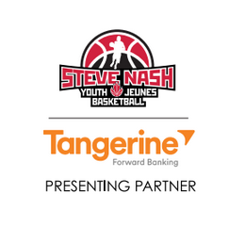
Campbell River Youth Basketball Association
Steve Nash Youth Basketball Registration Form
Registration Deadline February 10, 2017
**space is limited, applications will be processed on a fist come first served basis**

Player Information
Name: _____________________ _____________________

First Last

Address: _____________________ _____________________ ____________

Street Address City Postal Code

Adtl. Info: _____________________ _____________________ _______________

Home Phone E-mail Birthday (mm/dd/yy)

Gender: Boy Girl

Age Group (Grade): 4 5 6 7 8 9

Jersey Size (Y=Youth/A = Adult): YS YM YL AS AM AL AXL

Parents: _______________________________ _____________________________
Mother’s Name & Phone # (if different) Father’s Name & Phone # (if different)

Parental Consent & Indemnity Agreement
(Players will not be assigned to a team unless signed.)
I consent to and assume all risks and hazards of and incidental to the participation of the above-named boy or girl in the activities of (Insert Your Association Name) and agree to indemnify the said Association and its officers, servants or agents nominated or appointed by or on its behalf against all loss from any claim hereafter made against it, them or any of them by or on behalf of the said boy or girl and arising directly or indirectly from such participation.

______________________ _____________________________________________
Date Signature of Parent

__________________________________________
Print name of signatory above

Payment Information
(Please write player’s name on front of the cheque. Make cheques payable to Campbell River Steve Nash Basketball.)
Paid by: Cheque ($60.00) Cash ($60.00)

Volunteer Opportunities
I, __________________(insert name) am willing to volunteer to assist with: _________
(coaching, scheduling, administration, gym supervision, etc.)

