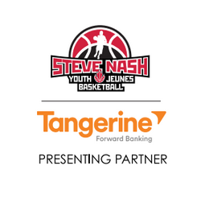
Students, parents, coaches!

We are very pleased to announce the 2nd annual Campbell River Steve Nash Youth Basketball Program!

Campbell River is part of the long list of communities throughout BC and across North America to benefit from the Steve Nash Youth Basketball Program. Our program follows the general Steve Nash endorsed Youth Skills development program. This year we are expanding to include grades 4 & 5. All kids are encouraged to sign up regardless of skill level. The aim of the program is to help develop and improve technical basketball skills in a fun and exciting environment.

Program details are as follows:

Location: Timberline Gym

Times and Dates:
Grades 4 & 5-Tuesdays from 3:30pm-4:30pm February 28, 2017- April 25, 2017
Grades 6 & 7-Wednesdays from 4:00pm-5:00pm March 1, 2017- April 26, 2017
Grades 8 & 9-Wednesdays from 5:15pm-6:15pm March 1, 2017- April 26, 2017

No sessions during Spring Break
Groups may be adjusted according to registration numbers and ages
Cost: $60 per student and includes a Steve Nash Youth basketball jersey

Please register using the proper registration form. Registration forms and payment to be dropped off in a sealed envelope at the Timberline School Office. Register soon, space is limited!

Looking forward to a great program!

Sincerely,

The Campbell River Steve Nash Youth Basketball Team

For more information contact Andrew Smith at 250-203-8563 or Ian Borenheim at 250-202-9315 or log onto http://www.basketball.bc.ca/snyb-home

